**Name – Akshat Jaiswal**

**Roll No. – 21052646**

**Section – CSE 37**

**DSA LAB 1**

1. **WAP to test whether a number num (num is entered through keyboard) is a prime number or not.**

**Input:**

#include <stdio.h>

*void* LCM();

*int* main (*void*)

{

*int* x,y,a,b;

    printf("Enter two numbers : ");

    scanf("%d%d",&x,&y);

    LCM(x,y);

}

*void* LCM(*int* *x*,*int* *y*){

*int* a,b;

      a=*x*;b=*y*;

    while (a!=b)

        {

            if (a<b)

            a=a+*x*;

            else

            b=b+*y*;

        }

        printf("LCM of %d and %d => %d\n",*x*,*y*,a);

}

**Output:**

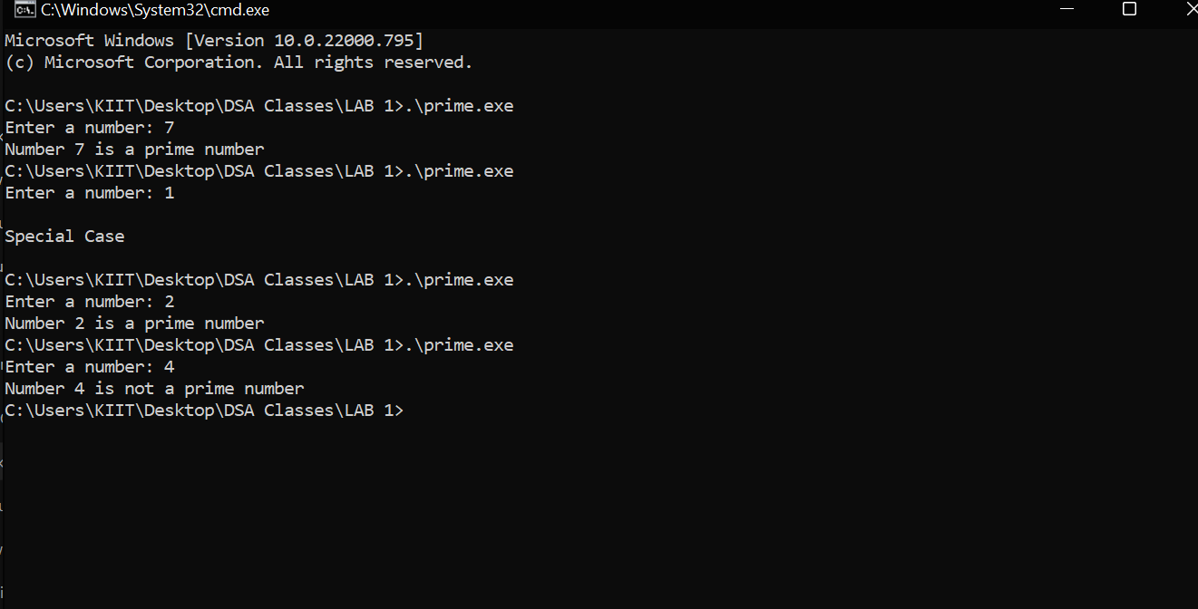

1. **WAP to calculate xy  using function.**

**Input:**

#include <stdio.h>

#include <math.h>

*int* main (*void*)

{

*int* x,y,c;

  printf("Enter the value of x: ");

  scanf("%d",&x);

  fflush(stdin);

  printf("Enter the value of y: ");

  scanf("%d",&y);

  c = power(x,y);

  printf("Result: %d",c);

return 0;

}

*int* power(*int* *x*,*int* *y*)

{

*int* result=1;

  while(*y*!=0)

  {

   result =result\**x*;

*y*--;

  }

    return result;

}

**Output:**

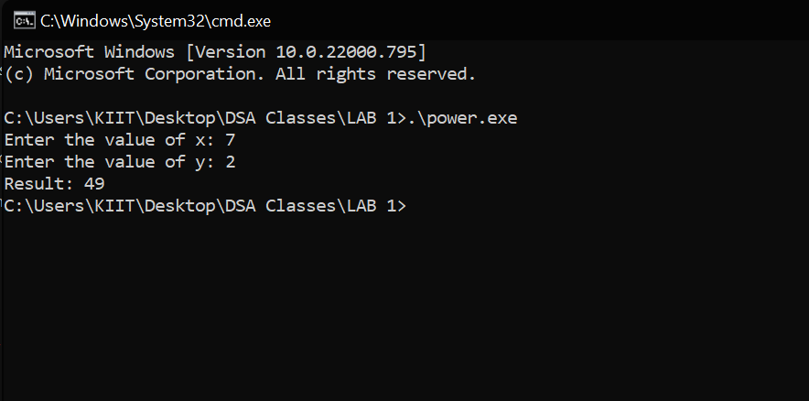

1. **WAP to find the LCM of two numbers a and b by using a suitable function (say LCM) for this.**

**Input:** #include <stdio.h>

*void* LCM();

*int* main (*void*)

{

*int* x,y,a,b;

    printf("Enter two numbers : ");

    scanf("%d%d",&x,&y);

    LCM(x,y);

}

*void* LCM(*int* *x*,*int* *y*){

*int* a,b;

      a=*x*;b=*y*;

    while (a!=b)

        {

            if (a<b)

            a=a+*x*;

            else

            b=b+*y*;

        }

        printf("LCM of %d and %d => %d\n",*x*,*y*,a);

}

**Output:** 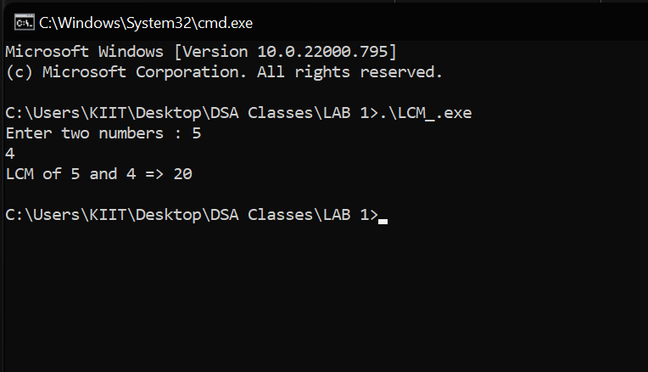

1. **WAP to perform the add, sub, mul, & div operations based on functions.**

**Input:** #include <stdio.h>

*int* add();

*int* sub();

*int* mul();

*int* div();

*int* main (*void*)

{

*int* a,b;

  printf("Enter the first number: ");

  scanf ("%d",&a);

  fflush(stdin);

  printf("Enter the second number: ");

  scanf ("%d",&b);

*int* p=add(a,b);

  printf("Addition : %d\n",p);

*int* q=sub(a,b);

  printf("Subtraction : %d\n",q);

*int* s=mul(a,b);

  printf("Multiplication : %d\n",s);

*int* t=div(a,b);

  printf("Division : %d\n",t);

return 0;

}

*int* add(*int* *x*,*int* *y*)

{

*int* result = *x*+*y*;

  return result;

}

*int* sub(*int* *x*,*int* *y*)

{

*int* result = *x*-*y*;

  return result;

}

*int* mul(*int* *x*,*int* *y*)

{

*int* result = *x*\**y*;

  return result;

}

*int* div(*int* *x*,*int* *y*)

{

*int* result = *x*/*y*;

  return result;

}

**Output:**

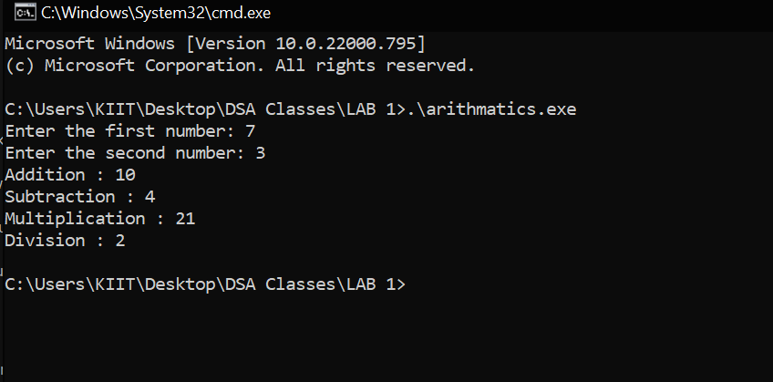

1. **WAP to create, initialize, assign and access a pointer variable.**

**Input:**

#include <stdio.h>

*int* main (*void*)

{

*int* i;

*int* *j;

  printf("Enter the value of i: ");

  scanf("%d",&i);

  j=&i;

  printf("The value of i is %d\n",i);

  printf("The address of i is %u\n",j);

return 0;

}

**Output:**

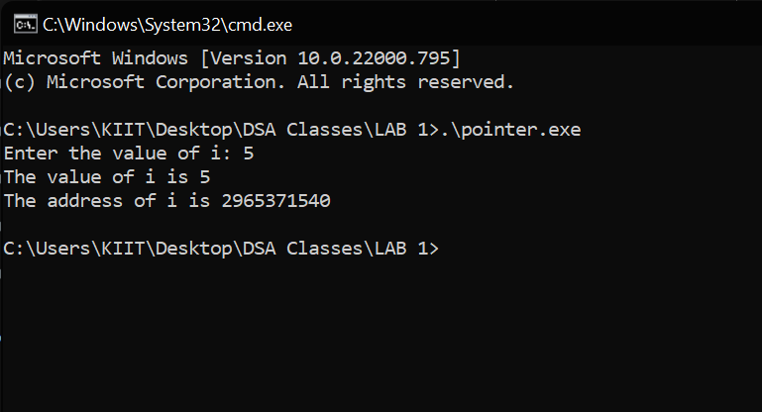

1. **WAP to add two numbers using pointers.**

**Input:** #include <stdio.h>

*int* main (*void*)

{

*int* a,b,c;

*int* *x=&a,*y=&b;

  printf("Enter the value of a: ");

  scanf("%d",&a);

  fflush(stdin);

  printf("Enter the value of b: ");

  scanf("%d",&b);

  c=*x+*y;

  printf("The addition: %d",c);

return 0;

}

**Output:**

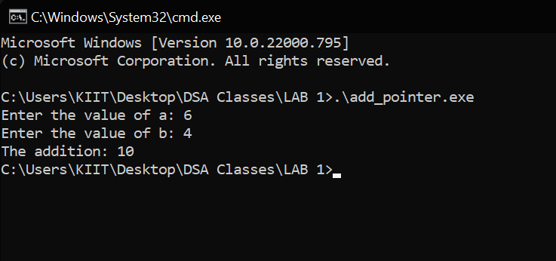

1. **WAP to swap two numbers using call by reference.**

**Input:** #include <stdio.h>

swap();

*int* main (*void*){

*int* a,b,c;

  printf("Enter the value of a: ");

  scanf("%d",&a);

  fflush(stdin);

  printf("Enter the value of b: ");

  scanf("%d",&b);

  printf("The value of a & b = %d & %d \n",a,b);

  swap(&a,&b);

  printf("\nAfter Swapping\n");

  printf("The value of a & b = %d & %d \n",a,b);

  return 0;

}

swap (*int* \**x*,*int* \**y*)

{

*int* temp = \**x*;

  \**x* = \**y*;

  \**y* = temp;

}

**Output:**

